**FINANCIAL DASHBOARD – EVEREST GROUP**

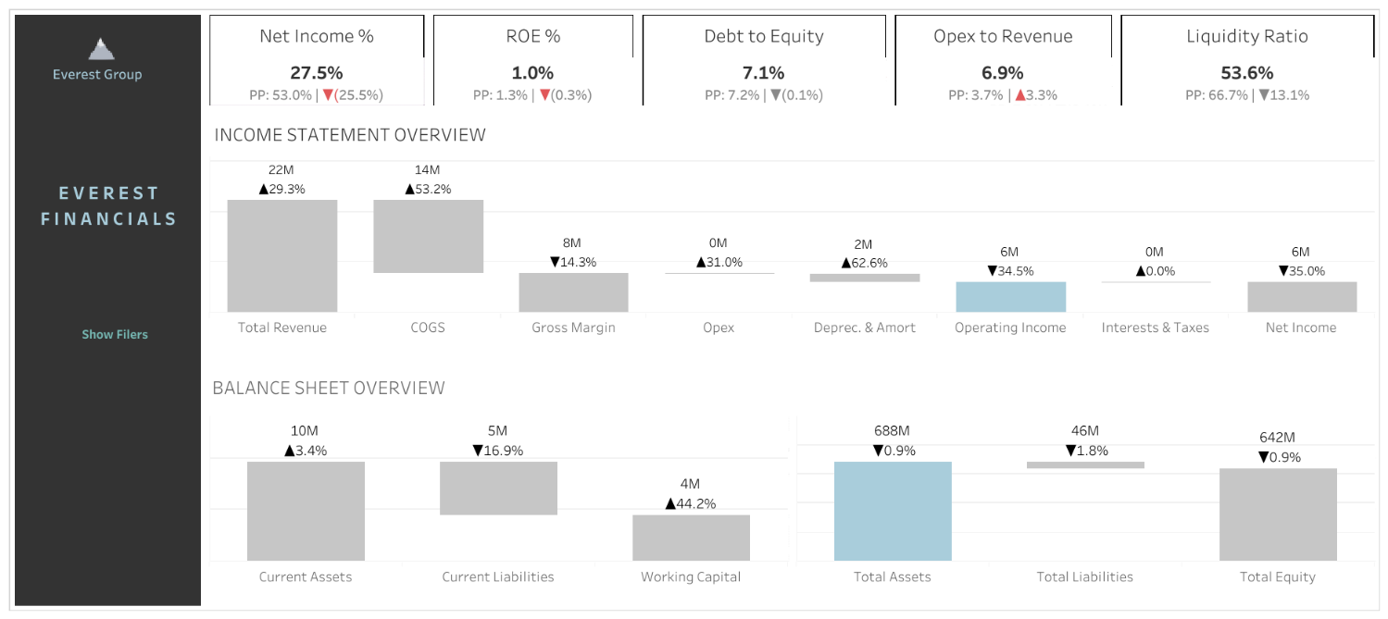

Financial statements provide a valuable source of information for stakeholders to evaluate a company's financial performance and position. They are used to make decisions about investing, lending, managing, and regulating companies, and are an essential tool for ensuring transparency and accountability in the business world.

**Data Attributes:**

* Month
* Company
* Depreciations Amortizations
* Taxes
* Operating Costs / COGS
* Operating Expenses
* Sales
* Current Assets
* Current Liabilities
* Assets
* Liabilities

**Data Preparation:**

To prepare the data for analysis, following checks were performed:-

* Duplicate Values
* Missing / Irrelevant Value
* Outliers
* Appropriate Data Type For Each Column

**Objective:**

* Calculate and present important financial parameters & ratios of the company:
* Net Income % Change
* Return On Equity (ROE)
* Debt To Equity
* Opex To Revenue
* Liquidity Ratio
* Display the Income Statement
* Display the Balance Sheet

**Link To Dashboard:**

<https://public.tableau.com/app/profile/gaurav.patil7479/viz/FinancialDashboard-EverestGroup/Dashboard2>